**Creation of Workspace in oracle 11g**

1. Start-> oracle 11g->go to database home page to open the following home page

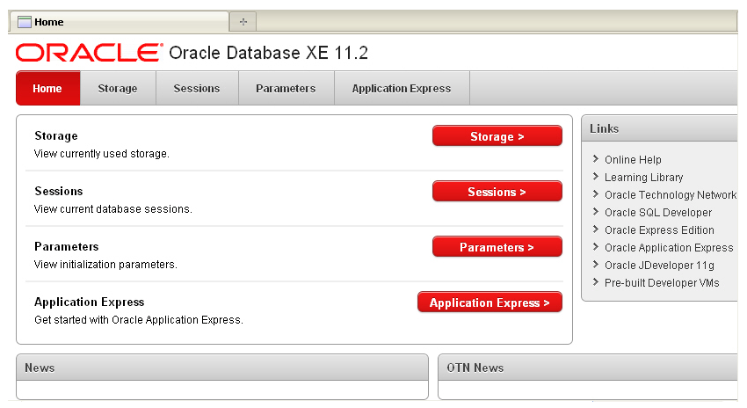

1. Click on Application Express

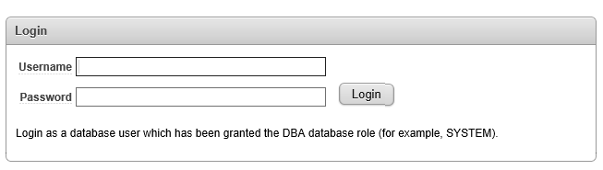

1. Login

Username: system

Password: system

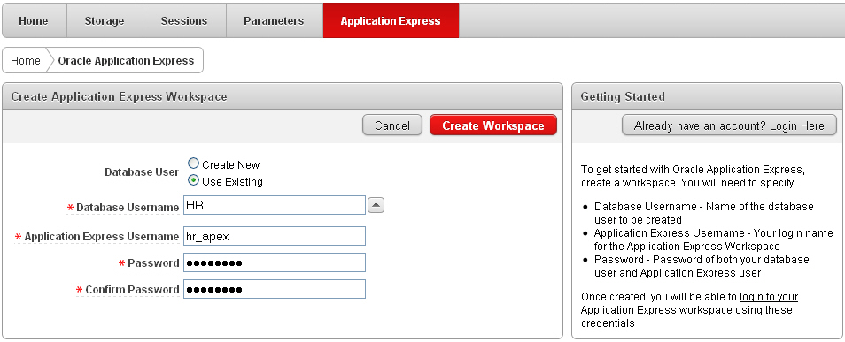

4.Now enter database name, username and password and click on create workspace.

5.Now click on login and enter your username and password.

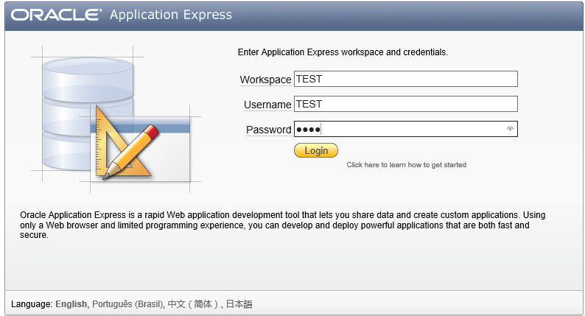

**Creation of tables:**

1.Select Object Browser

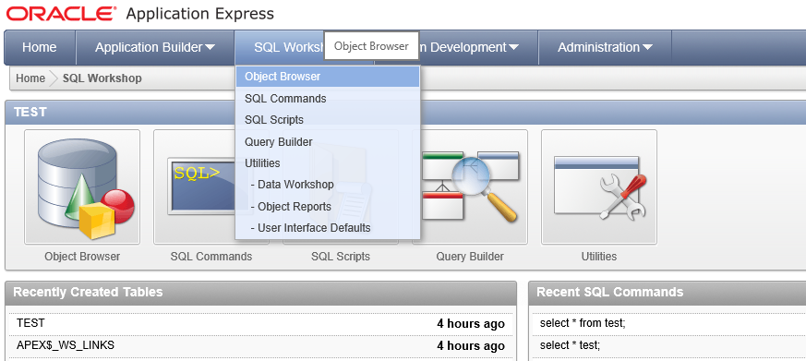

2. Click on Create and select table

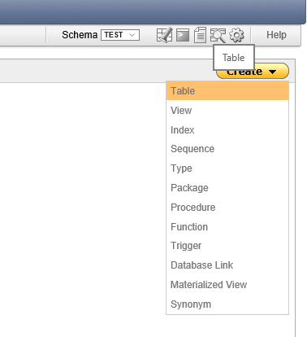

1. Add table name and all the columns of the table with appropriate datatypes and then click next

Enter table name

Add columns required. Select the proper data type(for eg. Id is a number so datatype selected is NUMBER, name is a string hence data type selected is VARCHAR2 (4000 is number of characters))

Not null is checked for primary key as the value of a primary key is necessary and it cannot be empty. If the value is neccessay for a particular column,Not Null is checked.

Once all the columns are added click on next.

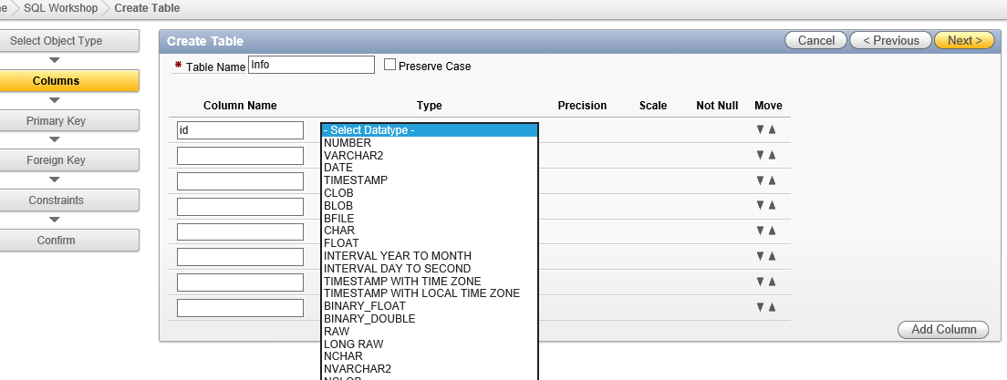

1. Select Primary Key

Select not populated primary key

Select the primary key for the table by clicking the dropdown .(for eg. Table info’s primary key is ID)

Click next.

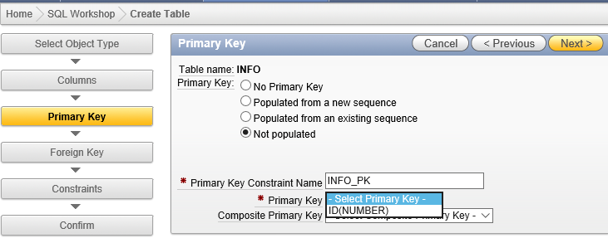

Step 5:

Click next

Click next

Step 4:

Click create.

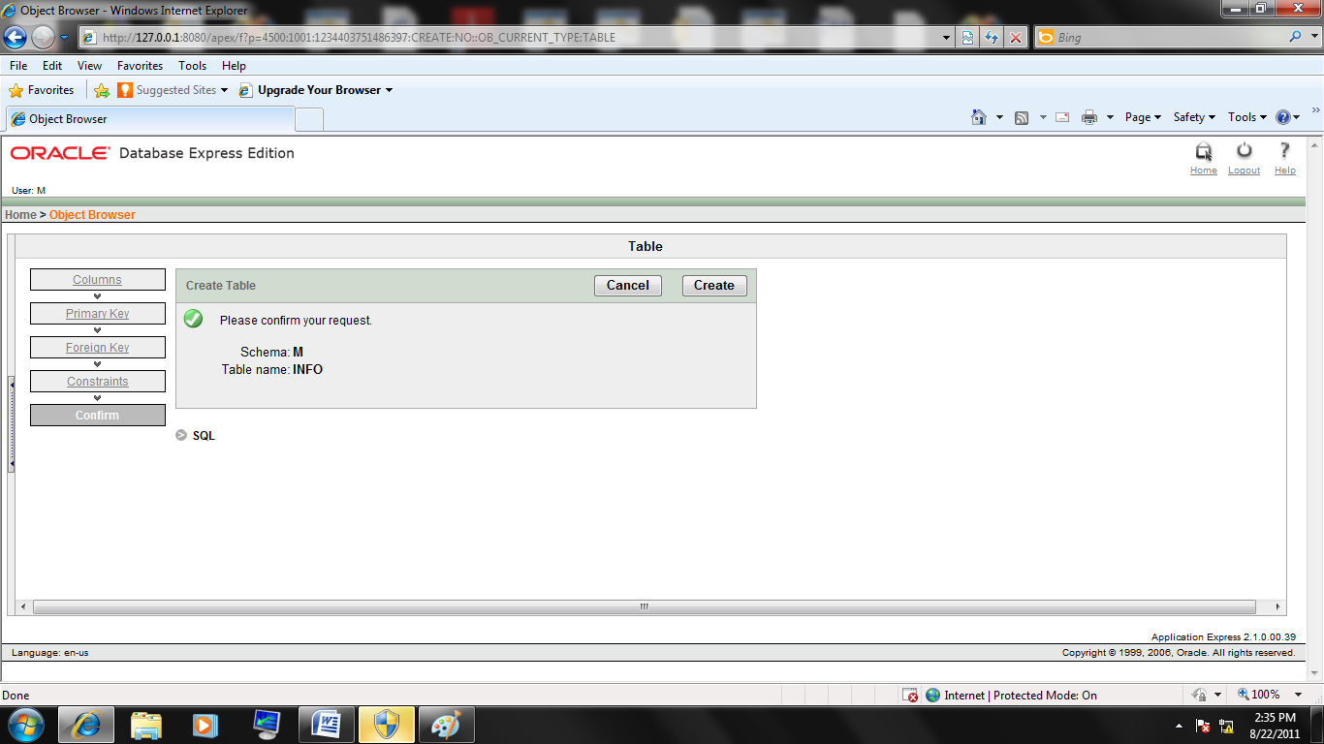

Table info is created .

Similarly create all other tables in the same database for your project (repeat 6 and 7 ).

1. Log out.